PLAGIARISM CHECKER

**Project Report**

***Submitted to***



SREYAS INSTITUTE OF ENGINEERING AND TECHNOLOGY

AUTONOMOUS

Saikiran Sagar.K (22VE1A6735)

Yashwanth Reddy.P (22VE1A6745)

Charan.P (22VE1A6747)

**Under the Guidance**

**Of**

**MR.NAGENDRA SAI**

SREYAS INSTITUTE OF ENGINEERING AND TECHNOLOGY

## DEPARTMENT OF CSE (DATA SCIENCE)

( Approved by A.I.C.T.E and Accredited by NAAC, New Delhi)

Bandlaguda, Beside Indu Aranya, Nagole, Ranga Reddy Dist, Hyderabad-500068

2022-2026



**SREYAS INSTITUTE OF ENGINEERING AND TECHNOLOGY**

**DEPARTMENT OF CSE (DATA SCIENCE)**

# CERTIFICATE

This is to certify that the Project Report entitled “PLAGIARISM CHECKER” is being submitted by SAIKIRANSAGAR.K (22VE1A6735), YASHWANTH REDDY.P (22VE1A6745), CHARAN.P (22VE1A6747) in partial fulfillment of the requirements for the award of the degree of Bachelor of Technology in CSE (DATA SCIENCE) from sreyas institute of engineering and technology, Tatti annaram, Hyderabad for the academic year 2023-24 is a record of bonafide work carried out by them under our guidance and Supervision.

**Guide** **Head of the Department**

**Mr.Nagendra sai** **Dr. M. Jayaram**

**Assistant Professor** **Professor**

**INDEX**

**LIST OF CONTENTS**

|  |  |  |
| --- | --- | --- |
| **Sno** | **Content** | **Pageno** |
|  | **Abstract** |  |
| 1 | Introduction |  |
| 2 | System Analysis |  |
|  | 2.1 Problem Statement |  |
|  | 2.2 Proposed solution |  |
| 3 | Requirement Specification |  |
|  | 3.1 Hardware requirements |  |
|  | 3.2 Software requirements |  |
| 4 | Methodology |  |
|  | 4.1 History |  |
|  | 4.2 How it works |  |
|  | 4.3 Uses |  |
|  | 4.4 Drawbacks |  |
| 5 | Coding |  |
| 6 | System testing |  |
|  | 6.1 Stimulation & test results |  |
| 7 | Conclusion |  |

**List of Screenshots**

|  |  |  |
| --- | --- | --- |
| **Sno** | **Content** | **Pageno** |
|  | **Plagiarism Output** |  |

**ABSTRACT**

A plagiarism checker is a tool that helps to check text originality, verify authorship, and trace AI-generated content. It uses advanced AI algorithms to detect plagiarism in over 100 languages, including the slightest variations within the text, paraphrasing, and AI-generated content. The Copyleaks Plagiarism Checker, for instance, offers features such as the award-winning AI Content Detector, Codeleaks Source Code Detector, and the all-new Grammar Checker API. These features ensure that content is original, free of plagiarism, and grammatically correct. The platform also provides customizable scan report options, enabling users to control the data they want to see and share. With over 99% accuracy, full model coverage, and the ability to detect paraphrased AI-generated content, plagiarism checkers are essential for ensuring academic integrity and original content creation. Plagiarism is a serious offense that can result in severe consequences, including failing grades, academic probation, or even expulsion. Plagiarism checkers help users identify and prevent plagiarism in their work by using advanced AI algorithms to scan text and compare it to a vast database of online sources, including websites, academic journals, and books. Customizable scan report options and features such as the AI Content Detector, Codeleaks Source Code Detector, and Grammar Checker API make plagiarism checkers an ideal choice for users who want to ensure the originality and quality of their work

Plagiarism checkers use advanced AI algorithms to scan text and compare it to a vast database of online sources, including websites, academic journals, and books. The algorithms can detect even the slightest variations in text, including synonyms, paraphrasing, and AI-generated content. This ensures that users can trust that their work is original and free of plagiarism

**1.INTRODUCTION**

A plagiarism checker is tool designed to identify and highlight content that may have been copied or closely paraphrased from other sources. These tools help users, especially students and writers, ensure the originality of their work.

A plagiarism checker is a tool designed to ensure text originality, verify authorship, and trace AI-generated content. It utilizes advanced AI algorithms to detect plagiarism in over 100 languages, identifying even the slightest variations within the text, paraphrasing, and AI-generated content. Plagiarism checkers are essential for maintaining academic integrity and creating original content.

One such plagiarism checker is the Copyleaks Plagiarism Checker, which offers features such as the award-winning AI Content Detector, Codeleaks Source Code Detector, and the all-new Grammar Checker API. These features ensure that content is original, free of plagiarism, and grammatically correct. Additionally, Copyleaks provides customizable scan report options, enabling users to control the data they want to see and share.

Plagiarism is a serious offense that can lead to severe consequences, including failing grades, academic probation, or even expulsion. Plagiarism checkers help users identify and prevent plagiarism by using advanced AI algorithms to scan text and compare it to a vast database of online sources, including websites, academic journals, and books. The algorithms can detect even the slightest variations in text, including synonyms, paraphrasing, and AI-generated content, ensuring that users can trust that their work is original and free of plagiarism.

Customizable scan report options are another valuable feature of plagiarism checkers. These options enable users to control the data they want to see and share, which is particularly useful for teachers and professors who need to check multiple papers or assignments. They can customize the report to show only the information they need, such as plagiarism percentages, source links, and citation suggestions, saving time and ensuring that the grading process is fair and accurate.

Plagiarism checkers are not only useful for academic purposes but also for professionals who want to ensure the originality of their work. This includes writers, journalists, and content creators who need to create original content for their employers or clients. Plagiarism checkers can help these professionals avoid accidental plagiarism, which can result in legal consequences, damage to their reputation, and loss of business.

In conclusion, plagiarism checkers are essential tools for ensuring text originality, verifying authorship, and tracing AI-generated content. With advanced AI algorithms, customizable scan report options, and features such as the AI Content Detector, Codeleaks Source Code Detector, and Grammar Checker API, plagiarism checkers are a valuable resource for students, teachers, and professionals who want to ensure the originality and quality of their work. By using plagiarism checkers, users can avoid the consequences of plagiarism and maintain their academic and professional integrity

**2.SYSTEM ANALYSIS**

**2.1 Problem statement**

Plagiarism prevents individuals engaging deeply with the material, hindering their own learning and intellectual development, completely depends up on websites.

**2.2 Proposed solution**

Our tool is designed to identify potential plagiarism by comparing inputted text with existing sources. It aims to provide a reliable solution for detecting and preventing academic dishonesty.

**3.REQUIREMENTS SPECIFICATION**

**3.1 Hardware requirement**

System: Pentinum IV 2.4 GHz

Hard disk : 40GB

Monitor : 15 VGA Color

Ram :4GB

**3.2 Software requirement**

Operating system : windows

Coding language: Python

IDE: Visual studio code

**4.METHODOLOGY**

**4.1 History**

* In late 1980s, the design philosophy emphasized code readability and ease of use.
* Python 2.0 was released in 2000, introducing list comprehensions and garbage collection improvements.
* Python 3 introduced several syntactical and structural changes to enhance the languages consistency and clarity.
* In 2020s, It continues to evolve with regular releases introducing new features, optimizations and improvements.

**4.2 How a plagiarism works using Python ?**

Plagiarism checkers compare the text you submit against a vast database of academic and online content. They highlight similarities and provide a percentage indicating the extent of percentage indicating the extent of potential plagiarism.

**4.3 Uses**

It serve positive purposes such as promoting originality, maintaining academic and professional standards and protecting intellectual property.

Plagiarism involves the unethical use of someone else work without proper attribution.

**4.4 Drawbacks**

* Students can face severe academic penalties, including failing a course or expulsion from institution.
* In professional, it can lead to job loss, damage to one reputation.
* It prevents individuals engaging deeply with the material, hindering their own learning and intellectual development.
* It can harm the work of the original authors.

**5.CODING**

from difflib import SequenceMatcher

import sys

def print_similar_words(text1, text2):

    sequence_matcher = SequenceMatcher(None, text1.split(), text2.split())

    matches = sequence_matcher.get_matching_blocks()

    for match in matches:

        a, b, length = match

        words1 = text1.split()[a:a + length]

        words2 = text2.split()[b:b + length]

        print(f"Similar words: {words1}, {words2}")

def plagiarism_checker(text1, text2):

    if text1.strip() and text2.strip():

        text1 = text1.lower().split()

        text2 = text2.lower().split()

        sequence_matcher = SequenceMatcher(None, text1, text2)

        print(sequence_matcher)

        similarity_ratio = sequence_matcher.ratio()

        return similarity_ratio

    else:

        return 0

**6.SYSTEM TEST RESULTS**

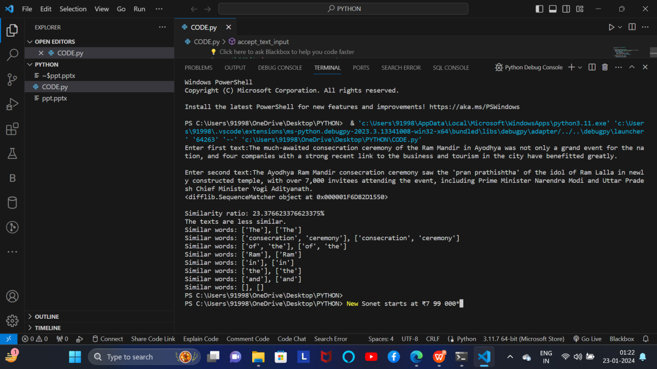

Fig. Plagiarism Output

**7.CONCLUSION**

This paper offers a conceptual overview of “ PLAGIARISM” using the Python. Plagiarism checkers play a crucial role in upholding academic and professional integrity. By identifying of plagiarism they contribute to the maintenance of high ethical standards in education, publishing and various professional domains. However, its essential to recognize that the true value lies not only in the detection of plagiarism but also in fostering a culture of proper citation, attribution and respect for intellectual property. As users, understanding the limitations of these tools and actively engaging in ethical writing practices are paramount for personal and collective growth. Ultimately, the responsible use of information enhances the quality of academic and professional discourse, ensuring a foundation built on honesty, transparency and intellectual authenticity.

The project aimed to develop a robust tool for identifying potential plagiarism and has successfully achieved this objective.

As technology advances and content generation increases, the future of plagiarism detection will continue to evolve, impacting academic and professional fields.